**AWS EXERCISES**

VPC and EC2

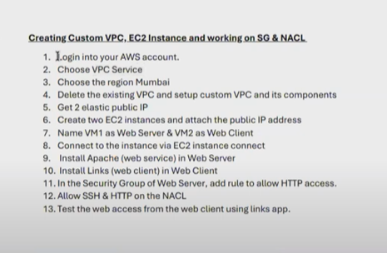

Step 1,2,3

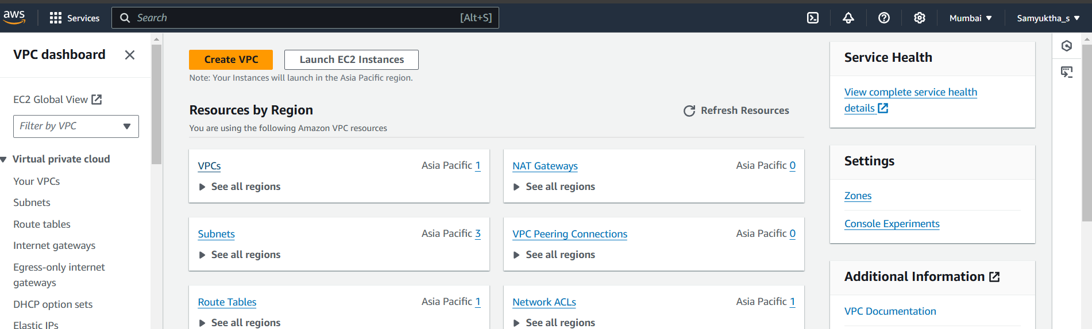



Step 4

Delete existing vpc, check and refresh subnets, internet gateways

Custom vpc name- snuc-dc-vpc

IP- 192.168.0.0/16

Don’t change any other setting

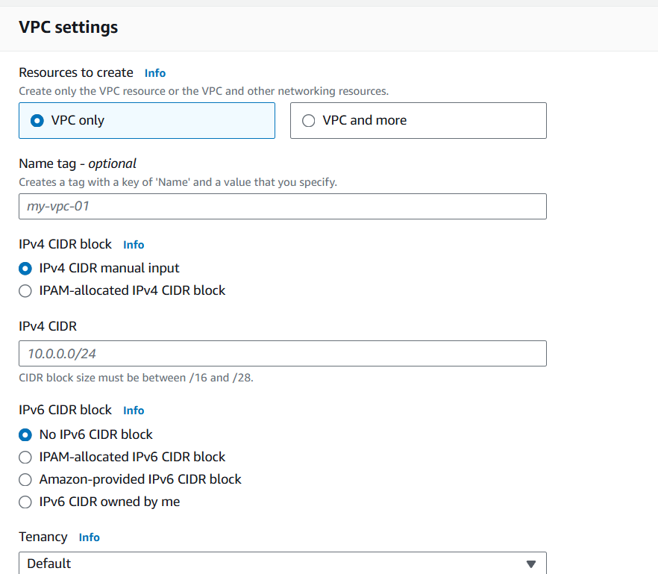

create subnet and internet gateway – attach to vpc

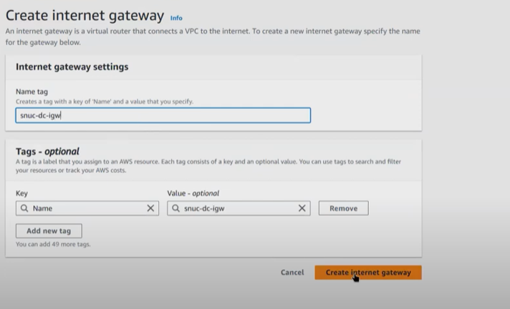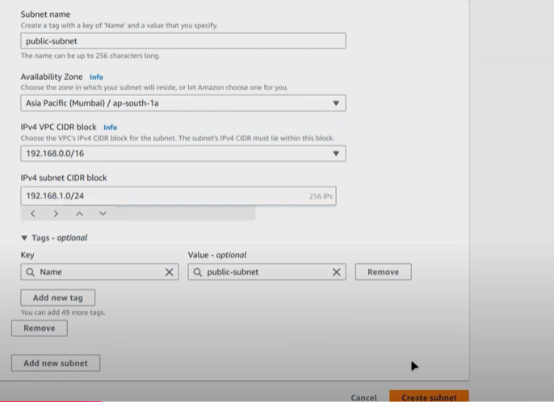

Route tables -> route table id -> routes -> edit routes -> add route ->

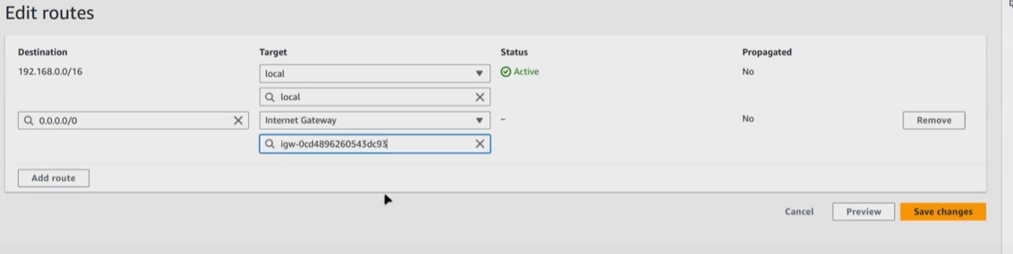

Step 5- get 2 elastic public ip

Elastic Ip ->

Step 6 – ec2 instance and attach public ip

Search ec2 -> instances -> launch 2 instances -> ubuntu ->key pair- proceed without and launch

Step 7- Instances -> rename both -> elastic ip -> associate elastic ip->

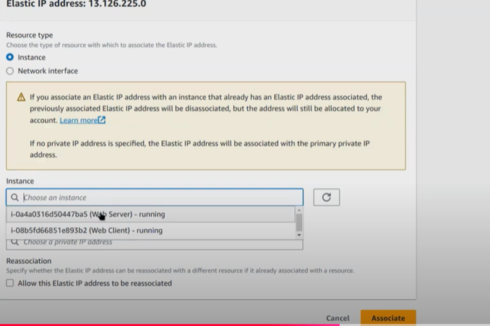

Step 8- ec2 instance- connect using ec2 instance- terminal is launched

Step 9- commands- web server

Ping 8.8.8.8

Sudo apt update

Sudo apt install apache

Sudo apt install apache2

Service apache2 status

Step 10- web client- launch terminal

Ping 8.8.8.8

Sudo apt update

Sudo apt install links

Step 11-

select web server instance-> instance id-> security -> security groups(click) -> edit inbound rules ->

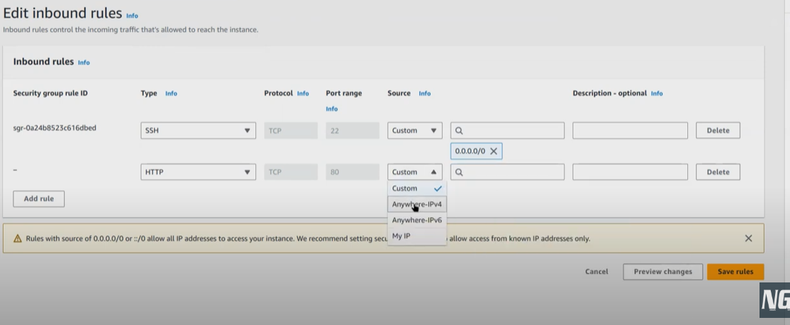

Step 12- ssh and http on nacl (not needed to perform)

VPC -> NACL -> select id -> edit inbound rules ->

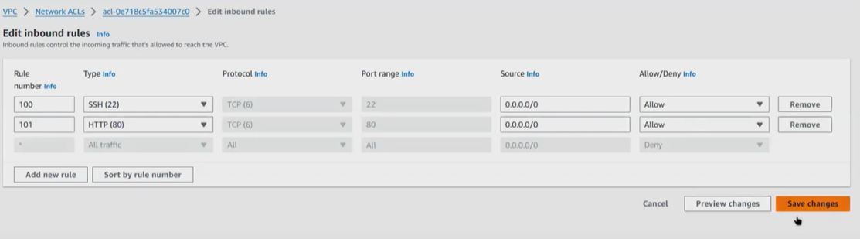

Step 13- copy ip of web server from its terminal

Go to client terminal -> type links and paste ip address

Links ip

Links http ip

**Route 53**

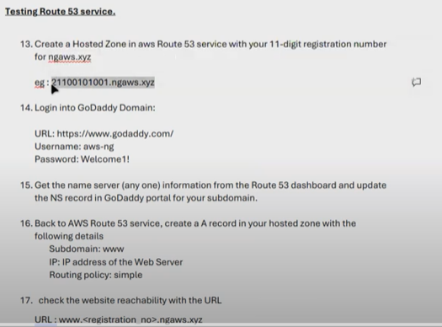

Step 1- create hosted zone

Perform step 2

Step 3-

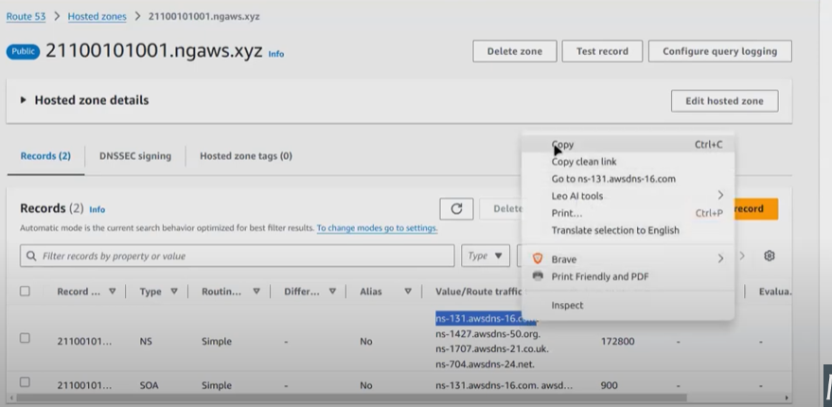

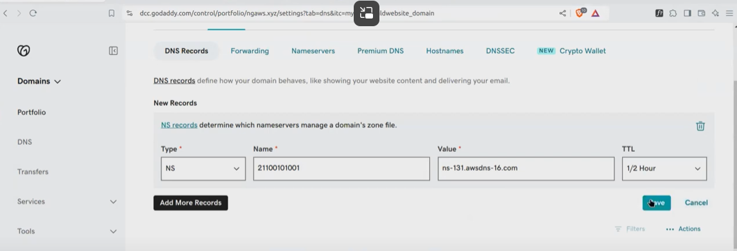

Step 4 -> route 53 -> create record with the details

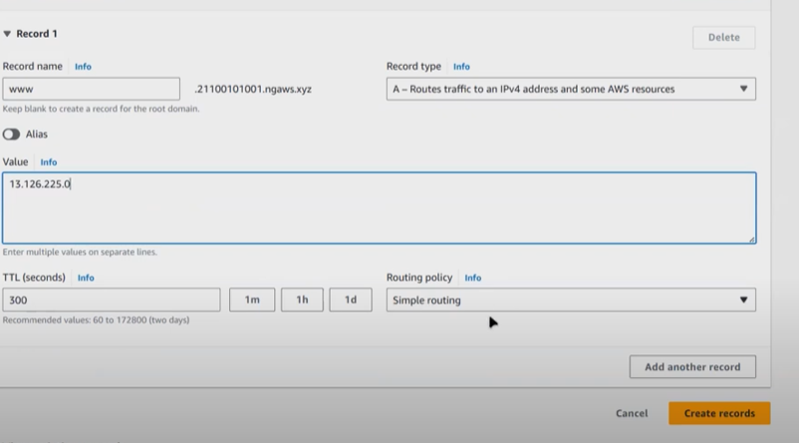

Step 5- go to web client terminal -> type

Links [www.reg_no.ngaws.xyz](http://www.reg_no.ngaws.xyz) to check